THREAD ROLLING MACHINE

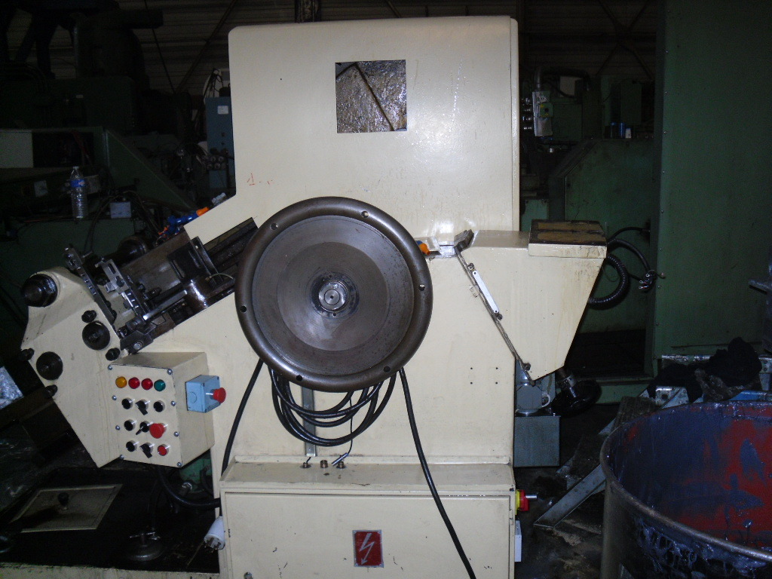

Make : SASPI

Type : GV-4-30
Year :

Specifications :

Thread workpiece Ø 6 - 14 mm

Power 16 kW

PPM 65 - 160

Dimensions 3 125 x1 200 x h 1 850 mm

Weight 5 600 kg

Equipped with :

These specifications are given in good faith and are correct to the best of our knowledge. Details are not binding.

